Project Design Phase-II
Technology Stack (Architecture & Stack)

Date | 18 JUNE 2026
Team ID
Project Name | Online Complaint Registration System
Maximum Marks | 4 Marks

Technical Architecture:

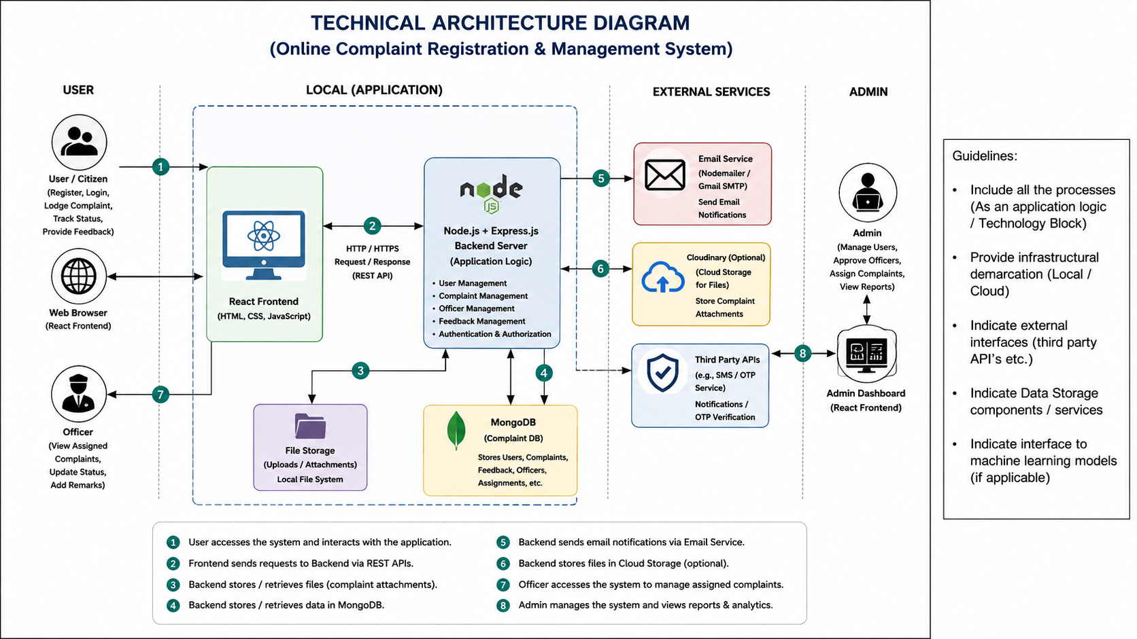
Table-1: Components & Technologies:

S.No | Component | Description | Technology
1 | User Interface | Web application for Users, Officers and Admins | React.js, HTML, CSS, JavaScript
2 | Application Logic | Authentication, Complaint Management, Feedback Management | Node.js, Express.js
3 | Database | Stores users, complaints, feedback and assignments | MongoDB
4 | API Communication | Communication between frontend and backend | REST APIs, Axios
5 | Security Layer | Authentication and Authorization | JWT, bcryptjs
6 | Admin Module | Complaint assignment and officer approval | React.js, Node.js
7 | Officer Module | Complaint resolution and status updates | React.js, Node.js
8 | Development Environment | Application runtime environment | VS Code, Node.js
9 | Infrastructure | MERN Stack Application | MongoDB, Express.js, React.js, Node.js

Table-2: Application Characteristics:

S.No | Characteristics | Description | Technology
1 | Frontend Framework | Interactive user interface | React.js
2 | Backend Framework | Business logic and APIs | Node.js, Express.js
3 | Database Management | Complaint and user data storage | MongoDB
4 | Security Implementation | Secure login and authentication | JWT, bcryptjs
5 | Communication Protocol | Frontend-backend communication | REST API, Axios
6 | File Handling | Complaint attachment management | Multer
7 | Notification Service | Email alerts and updates | Nodemailer
8 | Scalability | Modular MERN architecture | MERN Stack
9 | Availability | Accessible through web browser | Web Application
10 | Maintainability | Modular code structure | MVC Architecture
11 | Reliability | Accurate complaint tracking and status management | MongoDB + Express.js

References:
https://www.npmjs.com/package/jsonwebtoken
https://www.npmjs.com/package/bcryptjs

